Launching ceremony of Right Here Rights Now (RHRN)
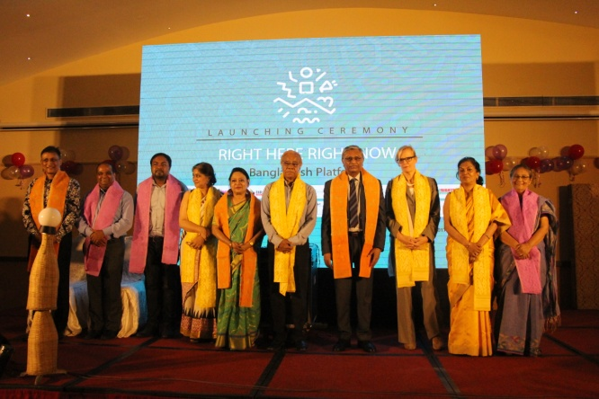
NHRCB Chairman Kazi Reazul Hoque graced as the Chief Guest the launching ceremony of Right Here Rights Now (RHRN), a strategic global partnership that bring together ten organizations and an alliance working in Bangladesh to ensure meaningful and inclusive youth participation in SRHR intervention. The ceremony was organized by Bandhu Social Welfare Society and held at Lakeshore hotel, Gulshan, Dhaka on 18 October 2017. H. E. Leoni Margaretha Cuelenaere, Ambassador, Embassy of the Kingdom of the Netherlands in Bangladesh attended the program as the Special Guest. The ceremony began with welcome remarks by Barrister Sara Hossain, Honorary Executive Director, BLAST.
Organisers honored Guests including NHRC Chairman showing token of appreciation
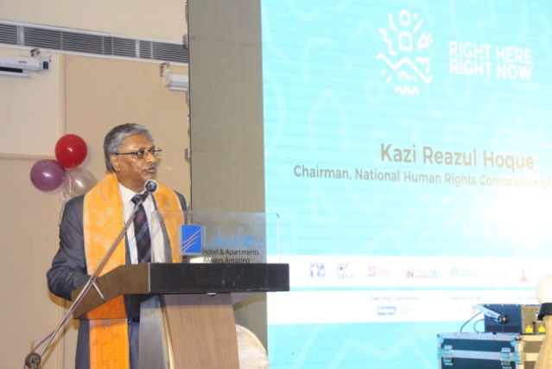
Kazi Reazul Hoque said in his speech, “It is my great pleasure to be present at this august gathering. The issue on which the 11 organisations have become united is very important to address now. Our youths are not empowered to take their uniformed decision. They are also not informed about Sexual and reproductive health and rights (SRHR). Thus, without right education, they become prone to HIV/AIDS, unwanted pregnancy and other related health problems. We need to aware family members and youths on these issues.” He also urged the government to identify third gender so that the third gender people need not go through the physical test.

